**Interrupt Processing II**

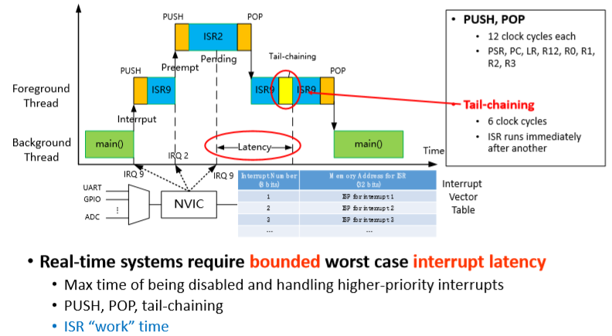Summary in Interrupt I:

* • (Mostly peripheral) events requiring attention → interrupt requests
* • Microcontroller stops to run interrupt service routine (ISR) • ISR can be executed between any two instructions
* • Microcontroller returns to code prior to interrupt
* • More efficient than polling for handling asynchronous events

Interrupt vector table

* Interrupt vector: starting memory address of an ISR
* • Table lookup via interrupt number (8 bits, signed)

Nested vectored interrupt controller (NVIC)

* Prioritizes and handles all interrupts
* • Preempt priority number for preemption
* • Sub-priority number for ordering interrupts with same preempt priority

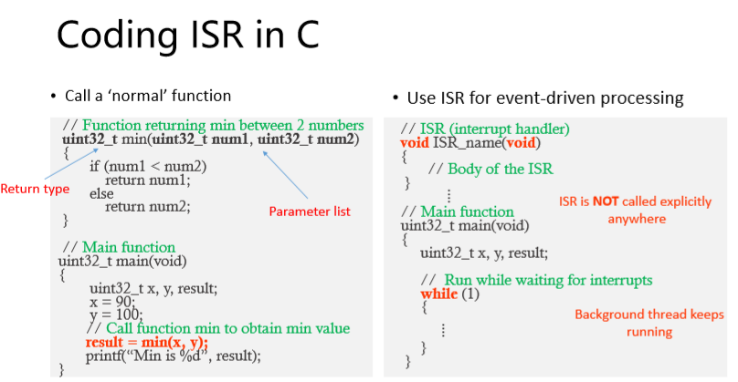**ISR as a Function**

• At interrupt, microcontroller stops to run ISR from a new address

* Similar to a ‘normal’ function call in C program
* Code ISR as a C function

• ‘Normal’ function vs. ISR

* 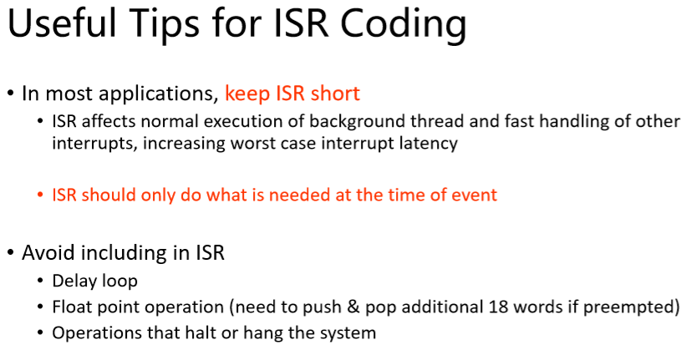‘Normal’ function call is user planned (programmed)
* Interrupt is asynchronous

Occurrence time may be unpredictable

ISR = do not know the exact time to call it.

Cannot predict when it will be called

ISR = has not input or return

ISR = should be short (**do not use any delay loop** with ISR) – don’t not use any floating point operations. Use global variables

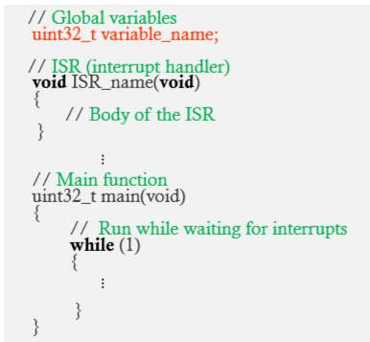**Inter-thread communication**

• Inter-thread communication through global memory

* Global variables defined outside of all functions

• Global variables

* 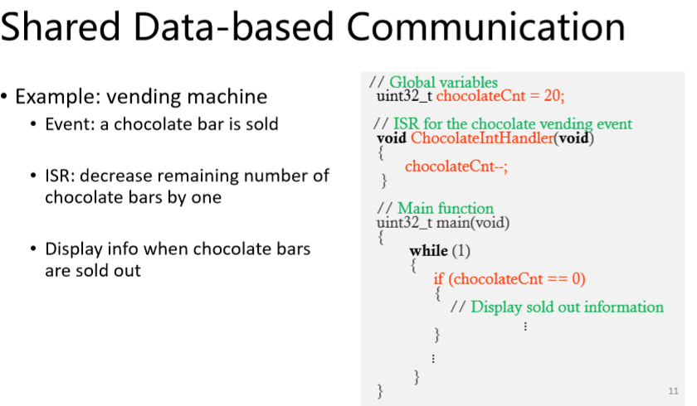 Data • Binary flag • Mailbox (binary flag + data) • Circular buffer …

**Binary Flag-based Communication**

• Shared data-based communication is one way to synchronize threads

• Binary flag is another way

* Set flag for signaling permission to perform certain operations
* Remember to clear flag

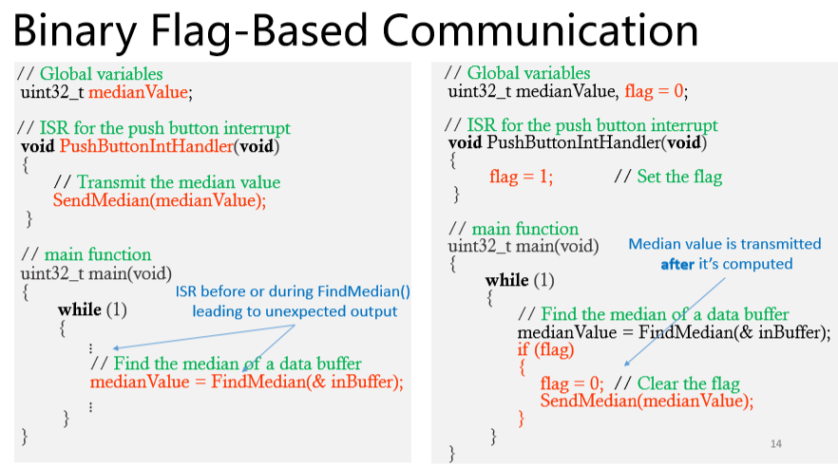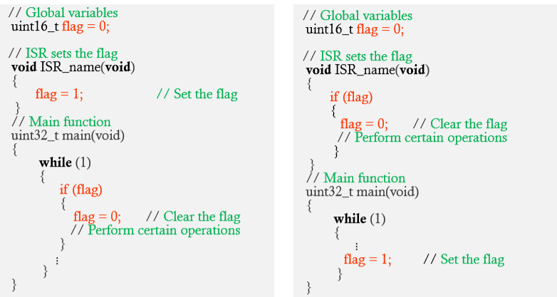• ISR sets flag vs. main() sets flag

